IConcept activity
Select a visual (photo or video) or auditory (sound bite, music clip) representation for each of the concepts listed below. CREATE a vision board or interactive concept map representing your understanding of each of the concepts.
Concept list – External influences on business
- Globalisation
- Technology
- Quality expectations
- Cost-based competition
- Government policies
- Legal regulation
- Environmental sustainability

SAMPLE
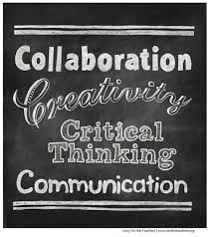

SUCCESS

