Transformation processes

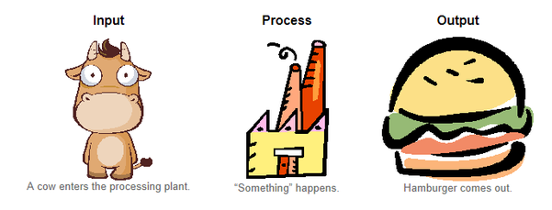
Transformation: the conversion of inputs (resources) into outputs (goods or services)
This includes physical changes (transformation of TANGIBLE products) through automation/mechanization as well as the conversion from resources into services (INTANGIBLE products) through the efforts of the organisations human resources.
Transformation processes are involved with the process of Value adding - The enhancement a company gives its product or service before offering the product to customers.
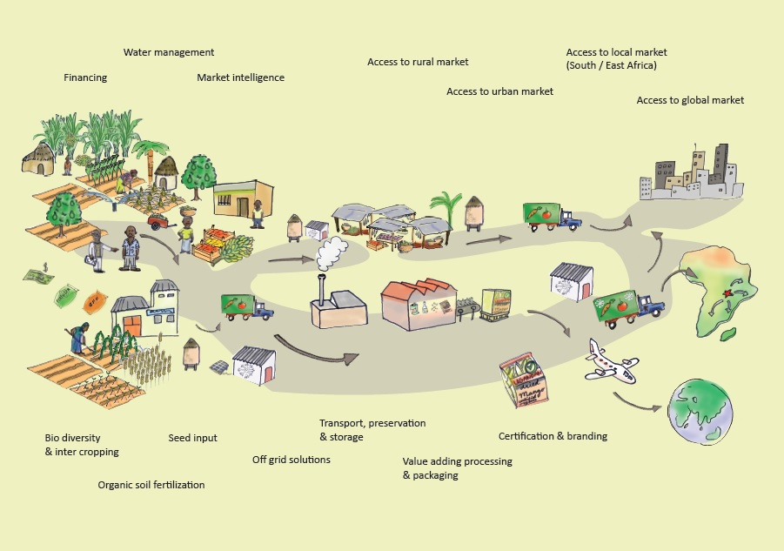
Q1: Explain the relationship between transformation and value adding.
Q2: What does the diagram above depict? How and where is value added?
Costs are incurred when something is created by manufacturing is processed or when a service is created. The addition of cost in transforming the inputs into a process (to turn into an output) ADDS value throughout this process.
Q3: How is value added in the service industry?
Operations processes relevant to transformation:
- Influence of volume, variety, demand and visibility
- Sequencing and scheduling (Gantt charts, critical path analysis)
- Technology, task design, plant (office/factory layout)
- Monitoring of processes, control of processes and improvement

Influence of volume, variety, demand and visibility
Influence of VOLUME | Influence of VARIETY
Volume – how much of a product will be made  Lead time – the time it takes from an order to be fulfilled from the moment it is made  Decisions need to be made about: How much to make, How much variation in product and demand, how much customer contact will there be (and if this should play a role in the transformation process)  Q4: How long is the average lead time at McDonald’s? How do you know? How does this compare to the design and delivery of a pair of custom Converse shoes? | Mix flexibility: the mix of products made, or services delivered, through the transformation process (aka ‘variety’ of choice, product range)  Dilemma: The greater the variety made, the more the operations process need to allow for variation.  Q5: Investigate the products made by Schweppes Australia. How do they manage to have a wide range of products while maintaining a narrow production process?  Q6: How does this differ from the approach taken by Unilever Australia?  Q7: What are some advantages and disadvantages of specialisation in a niche market, as opposed to variety? Provide examples to substantiate your answer.
Influence of VARIATION IN DEMAND | Influence of VISIBILITY (Customer contact)
A variation in demand can impact significantly on transformation resources; An increase in demand will require increased inputs from suppliers, human resources, energy use, and use of machinery and technology.  Q8: When might there be difficulties in meeting demand?  Q9: What are the implications of a decrease in demand?  Q10: How might these businesses predict demand:  - Toys’r’us  - An accounting firm  - L. J. Hooker | Customer contact (or, feedback) can directly affect transformation processes, as customer preferences can shape what businesses make. This may be through DIRECT or INDIRECT feedback.  Direct contact: feedback through surveys, interviews, warranty claims, letters, emails and blogs  Indirect contact: review of sales and market share data, observation of customer’s decision making through customer reviews.  Q11: How has the use of social media transformed the way customers provide feedback to business?

Q12: Select a physical product from a multinational business and describe the influence of volume, variety, demand and visibility on their transformation process.
Sequencing and Scheduling
Sequencing: the order in which activities in the operations process occur
Scheduling: the length of time activities in the operations process occur
When planning operations processes that involves activities central to transformation, various scheduling tools will be used. The two main tools are Gantt Charts and Critical Path Analysis (CPA).
Gantt chart: a type of bar chart that shows both the scheduled and completed work over a period of time. It is often used when planning and tracking a project. It outlines the activities that need to be performed, the order in which they need to be performed and the number of activities that need to be completed.
Advantages:
- They force a manager to plan the steps needed to complete a task and specify the amount of time required for each task
- They make it easy to monitor actual progress against planned activities.
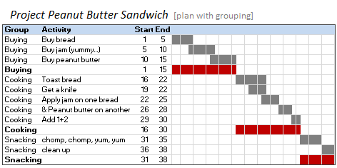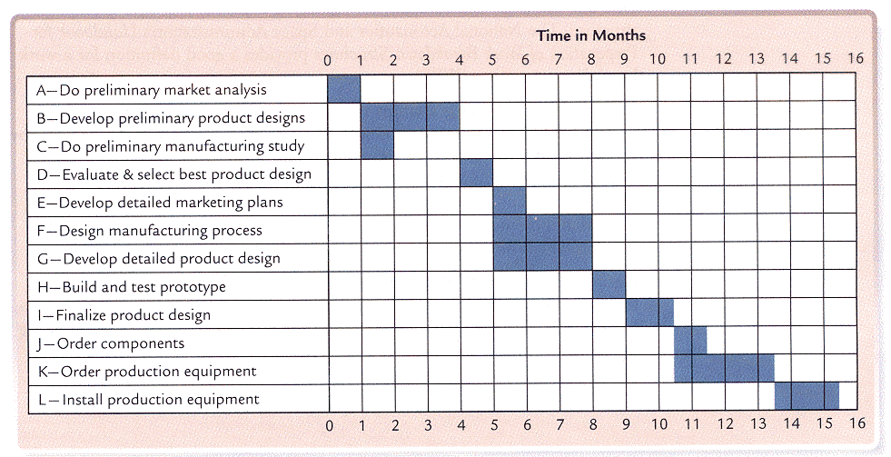
Q13: What do the above charts depict? How do they aid in managing a task or project?
Q14: Create a Gantt chart to plot your progress towards the Business studies HSC paper. Include all activities, assessments and proposed activities from now until the HSC (using months as your time increments).
Critical path analysis
Critical path analysis: a scheduling method or technique that shows what tasks need to be done, how long they take and what order is necessary to complete the tasks.
The critical path is the SHORTEST length of time it takes to complete ALL tasks necessary to complete the process or project.
Scheduling enables a manager to see what needs to be done and allows the timing of the tasks to be considered, thus allowing them to see which tasks can be done at the same time. This then gives direction and organisation to the operations processes, providing greater overall control and coordination.
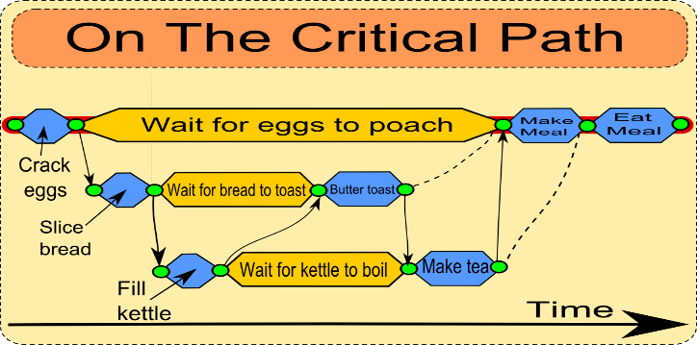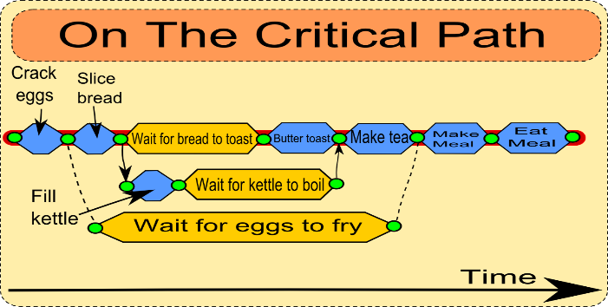
Q15: Using the data below, where none of the activities can be completed until foundation is applied, create a critical path analysis for the optimal time it would take to make up a face.
- Which activities can be done at the same time?
- What is the most and the least time consuming activity?
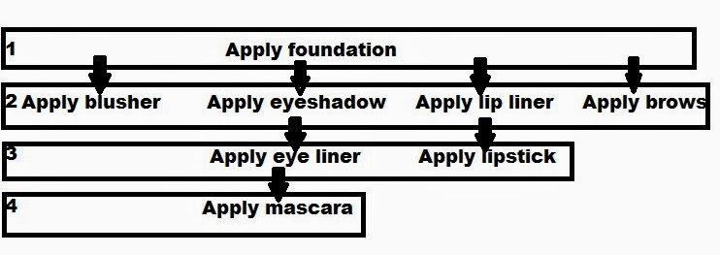
Technology
Technology is the application of science or knowledge that enables people to do new things or perform established tasks in new and better tasks.
Q16: How might technology be used to improve operations in both manufacturing and service industries?
Q17: What are the advantages of leasing, rather than purchasing, up-to-date technologies?
- Office technologies – the development of new technologies have enabled people to complete a greater number of tasks in less time, enabling work to become mobile and changing work patterns, where people increasingly telecommute (travel to work electronically) and work from home.
Q18: Brainstorm the various technology items that are commonplace in businesses today.
Q19: How could telecommuting change traditional patterns of work?
- Manufacturing technology – Robotics, CAD and CAM
Robotics: Highly specialised forms of technology capable of complex tasks. They are used in engineering, specialised research and on assembly lines where they shape transformation processes so they are consistent, efficient, of a high quality and minimise waste. However, they are generally cost prohibitive for smaller businesses.
Computer aided design (CAD): a computerised design tool that allows businesses to create product possibilities (generally 3D diagrams) from a series of input parameters
Computer aided manufacturing (CAM): software that controls manufacturing processes.
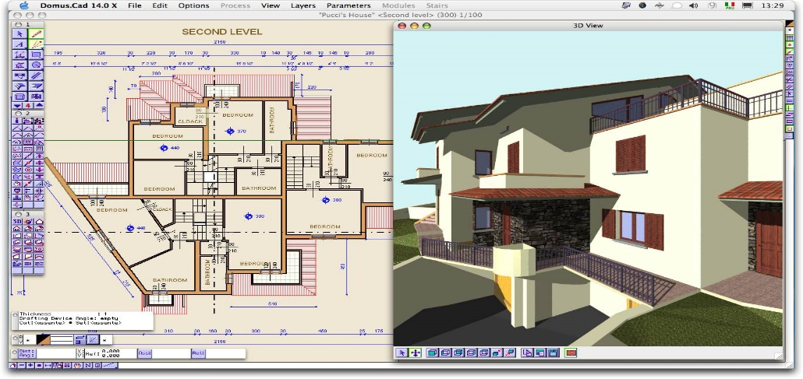
Using the above image, answer the questions below.
Q20a. How could CAD software be useful in customising a house for a client?
Q20b. How could CAD software be used to lead CAM in this diagram? (Hint: resources, financing)
Task design
Task design involves classifying job activities in ways that make it easy for an employee to successfully perform and complete that task.

It is necessary to group skills and competencies to ensure the right employees are hired for the job. A prospective employee will be screened against these skills and competencies to ensure a match.

Job analysis: who does what and why; used to improve a business’s productivity.
Sometimes, after investigation, a business may find that it has all the staff but not the requisite skills, and thus conducts a skills audit (A formal process used to determine the present level of skilling and any shortfalls that need to be made up through recruitment or training.
Q21: Why is task design so important?
Q23: What are the skills needed in the job advertisements above?
Layout
- Plant (factory/office) layout
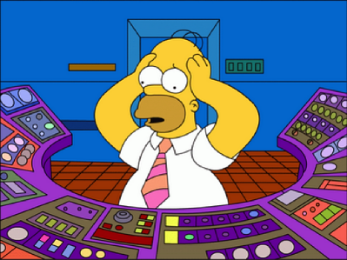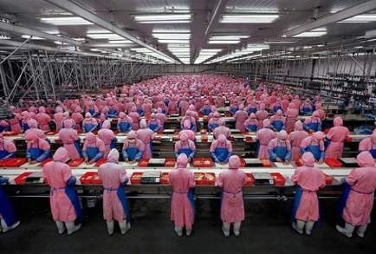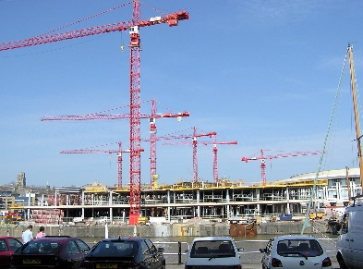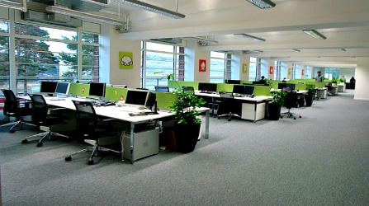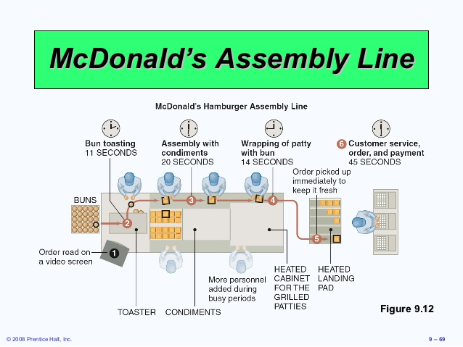
Above: Which layout is which?
Product layout: equipment arrangement relates to the sequence of tasks performed in manufacturing a product.
Process production: high variety, low volume production. Each product has a different sequence of production and the production is intermittent, moving from one department to another. Businesses often create work cells/teams to create combinations of machinery and equipment to produce a single product or a range of similar products.
Product production: (mass production) is characterised by the manufacturing of a high volume of consistently quality goods. An assembly line is the most common layout for this type of production, as it achieves the best possible use of equipment and employees (‘assembly line balancing’). This is referred to as a product layout, where the equipment arrangement relates to the sequence of tasks performed in manufacturing a product.
Project production: layout requirements for large-scale, bulky activities such as the construction of bridges, buildings and planes.
Fixed position layout: an operational arrangement in which employees and equipment come to the product.
Office layout – the focus of an office layout is to enable the professional to perform their work efficiently, with minimal disruption. Typically, the office is set around workstations (desk areas required by office workers; usually fitted with access to a computer, phone etc.). It is usually designed for service-based businesses to provide maximum workflow.
Q24: What considerations must managers make in matching employees and equipment to the task required? Illustrate with examples.
Q25: Which layout might a manufacturer use in assembling an Apple Mac? Justify your answer.
Q26: Discuss the benefits and disadvantages of an ‘open office plan’ in facilitating productive work flow for a business.

Monitoring, control and improvement
To continuously improve, all operations processes should be monitored for their effectiveness and subject to controls. With a focus on quality and standards, there is an improvement in the transformation process.
Monitoring: the process of measuring actual performance against planned performance. It involves measuring all aspects of performance from inputs to outputs. They are measured around the goals and needs of the business through Key Performance Indicators (KPIs)
KPI: A predetermined variable that is measured so that appropriate controls to processes can be made. They may include:
- Lead time/wait times
- Inventory/stock rates
- Defect rates, repair rates and warranty claims
- Process flow rates
- IT and maintenance costs
- Direct and indirect cost analysis
Monitoring KPIs allows businesses to measure their businesses actual performance against their targeted performance.
Control: when KPIs are assessed against predetermined targets and corrective action is taken if required. (I.e. comparing what is intended to happen and what has actually happened). This can be done through setting challenging bus reasonable performance goals and then reviewing them regularly.
Improvement: a systematic reduction of inefficacies and wastage, poor work processes and the elimination of any bottlenecks.
Bottleneck: An aspect of the transformation process that slows down the overall processing speed or creates an impediment leading to a backlog of incompletely processed products.
Q27: Explain why controls are an important part of the production process
Q28: What actions will you take to improve your performance in Business studies?
Improvement is typically sought in:
Time –
Process flows –
Quality –
Cost –
Efficiency –
Q29: How could improvement be made in the areas listed above? Discuss as a class.
One approach to the systematic reduction of inefficiencies and the active creation of improvements is called ‘Six Sigma’ as shown below.
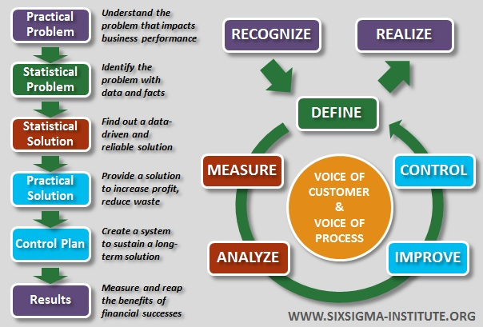
Q30: What is the most optimal layout for your classroom? Identify how both you and your teacher could implement performance goals to work towards maximising your performance in school while maintaining your wellbeing.

